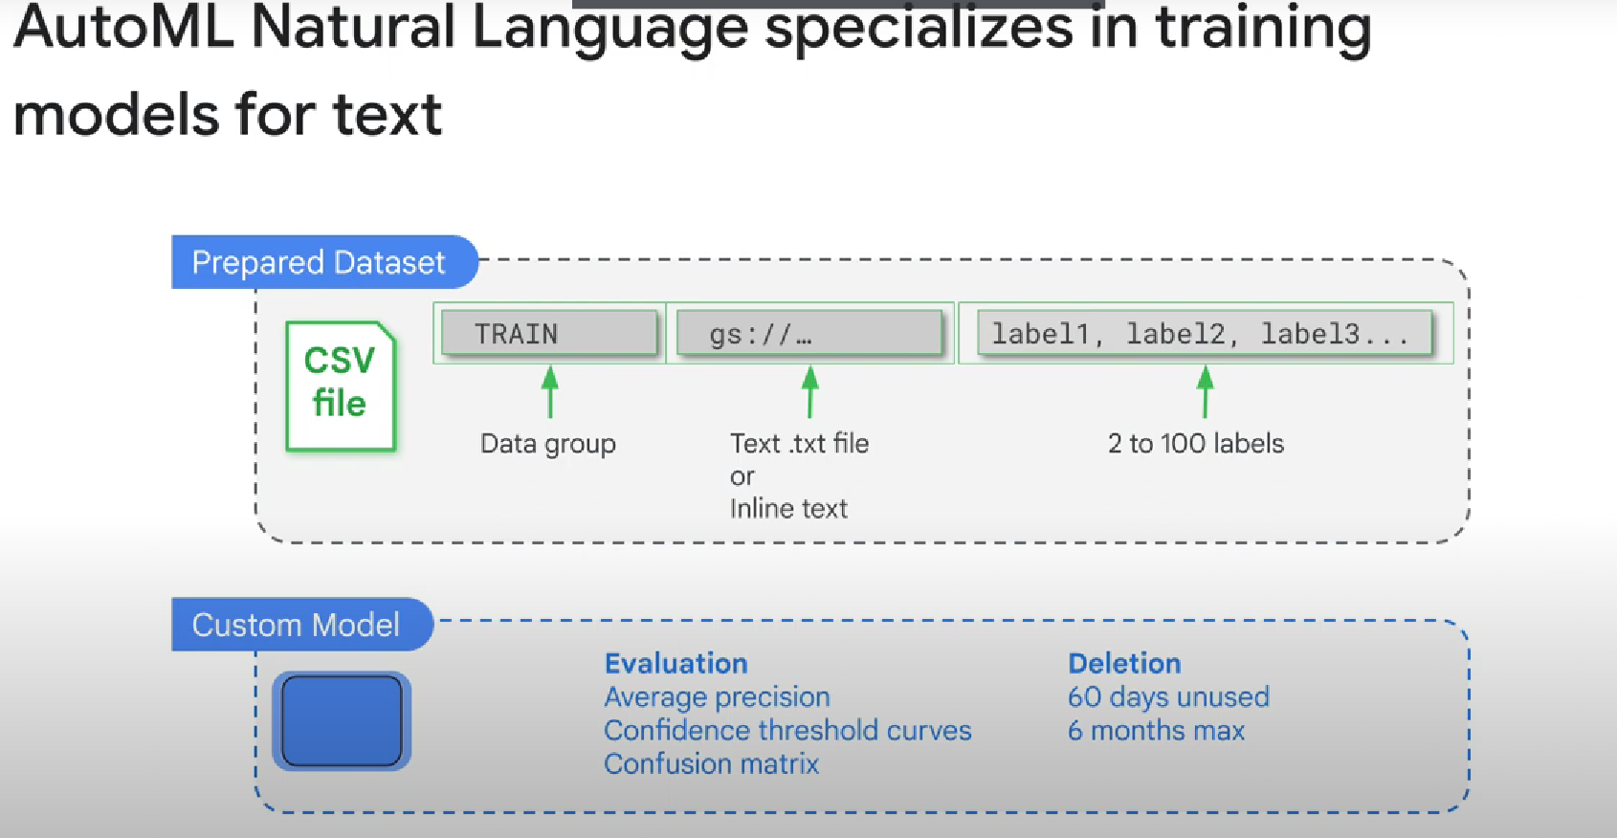

Note: The documents can be as small as one sentence or up to a **maximum of 128 kilobytes**

 If a natural language custom model is not used for **60 days, it will be deleted.**

If a natural language custom model is being **used, it will be deleted after 6 months.** To reserve a model, you'll be required to retrain it. The training and serving methods inside AutoML

The training and serving methods inside AutoML are frequently improved and updated. These changes are not guaranteed to be backwardly compatible. They may render a custom model incompatible with the current service, so you should plan to periodically regenerate

High confusion and low average precision scores indicate that a prepared data set needs additional entries or that the labels are being used inconsistently.

You may be able to improve low-quality evaluations for particular labels with one of these methods. - Add more documents associated with those labels. In other words, there might just not be enough training data

- You also may need to increase the variety of documents by adding longer or shorter examples, documents with different writing styles or word choice, or by different authors.

- Finally, **for labels that are not useful or have low quality, you may want to remove them altogether** to increase the accuracy of the remaining labels.